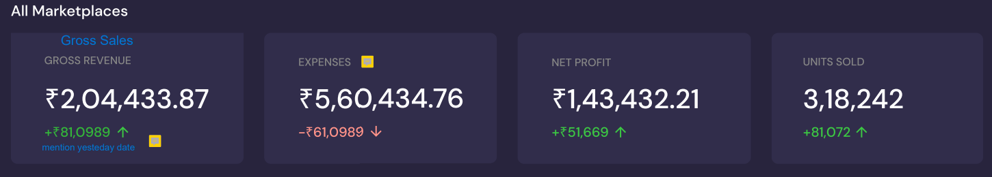

**Gross Sales** = Sum of column P to W, in Orders Report.



**Expense** = Marketplace Fee + Cogs + Ad spends

Marketplace Fee =

Cogs = Number of units sold * Product Cost

Ad Spends = Sponsored Product – advertised product spends + Sponsored Display- advertised product ad spends + Sponsored brand ad spends.

**Sponsored Brand Spends can only be shown at account level only.

**Net Profit** = Gross Sales – Expenses.

**Units sold** = Column N from Orders Report.

**AOV** (Average Order Value) = Gross Sales/Units Sold.

**Margin** = Net Profit/Gross Sales * 100.

**ROI** = Net Profit/Cogs * 100.

Units Returned =

**Page Views** = From child_asin_sales_and_traffic.

**Conversion Rates** = Units Sold/Page Views.

**Zones.**

**As per Amazon**

|  |  |
| --- | --- |
|  | List of shipping regions: |
| North | Region 1 - (Chandigarh, Delhi, Haryana, Himachal Pradesh, Jammu and Kashmir, Punjab, Rajasthan, Uttar Pradesh - Zone A*** and Uttarakhand). |
| West | Region 2 - (Dadar and Nagar, Diu and Daman, Gujarat, Madhya Pradesh, Maharashtra) |
| South | Region 3 - (Andaman and Nicobar, Andhra Pradesh, Goa, Karnataka, Kerala, Pondicherry, Tamil Nadu, Telangana, Lakshadweep). |
| East | Region 4 - (Arunachal Pradesh, Assam, Bihar, Chhattisgarh, Jharkhand, Manipur, Meghalaya, Mizoram, Nagaland, Odisha, Sikkim, Tripura, Uttar Pradesh-Zone B**, West Bengal). |
|  | **Uttar Pradesh-Zone B: The following administrative divisions will be considered as part of Uttar Pradesh-Zone B - Ayodhya, Azamgarh, Basti, Devipatan, Gorakhpur, Mirzapur, Prayagraj and Varanasi. |
|  | ***Uttar Pradesh-Zone A: All administrative divisions in the state of Uttar Pradesh that are not part of Uttar Pradesh-Zone B. |



**Return Rate** = Returns/Units Sold * 100.

**API’s**

**Orders Report** – Pull every 5 min.

**Settlement report** – Pull every day.

**child_asin_sales_and_traffi** –

Does not have accurate information regarding for what date range the data is pulled, hence need to store in such a way that we have its date range.

**Ads report** –

Does not have pull’s date in the report.

**Inventory Ledger** -

Sellable Qty = Disposition- “Sellable” – Warehouse Ending balance.

**Avg Daily Sales (30 days Sales)** = Average of last 30 days sale.

**Days of Inventory** = Sellable Qty/Avg Daily Sales.

**In stock Rate (30 days Sale)** = Sellable Qty / {Avg Daily Sales (30 days Sales) * 30**} \*** 100.

**Product Cost** = Input by user

**Value of stock** = Sellable Qty * Product Cost